2023
By Andrew Lee Creech

Dramaturg Packet
by Sonja Lowe
Taproot Theatre Company

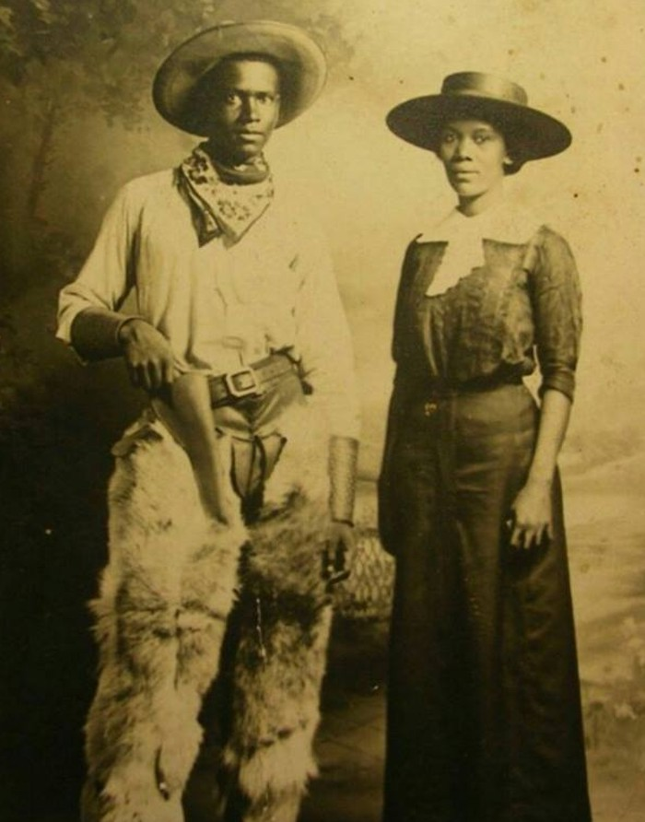
La st Drive to Dodge
Table of Contents
Playwright Bio page 2
Story of the Story page 3
Historical Timeline & U.S. Map 1880 page 4
Reconstruction history page 11

Reconstruction Timeline page 12

black Migration to the West page 13
Cattle Drives page 18

rancher history page 21
Terms and Cultural References page 22

PLAYWRIGHT BIO: Andrew Lee creech
Andrew (he/him) is an award-winning writer, performer, and content creator, currently based in Seattle, WA. He is the creator of The Legacy Plays Project—a nine-play, multi-century-spanning meditation on the lives and journeys of Black Americans during pivotal moments of American History. Selected Awards & Nominations: 2023-2026 Core Writer—Playwrights' Center, 2023 Finalist—Seven Devils Playwrights Conference, 2022 Semifinalist—Blue Ink Award, 2021 Winner and 2020 Finalist—Ashland New Plays Festival, 2021 Recipient—Grants for Artists' Progress Award, 2018 Recipient—4Culture Art Projects Grant, 2018 Gregory Awards People’s Choice Nominee for Outstanding New Play, 2014 Gypsy Rose Lee Award Nominee for Excellence in Performance of a Play as a Supporting Actor.
​His plays have been produced with companies including: Seattle Public Theater, Copious Love Productions, and Radial Theater Project, and have been workshopped, developed, and presented with ACT Theatre and more. As a performer, Andrew has been on many major Seattle stages including: Seattle Repertory Theatre, ACT Theatre, Seattle Shakespeare Company, and Seattle Children’s Theatre. As a content creator, under the names “AndrewThaScribe” and "Papadontcreech", he has built a community of over 90,000 followers across all social media platforms, where he is known for his theatre industry analysis and hit comedy series Breaking News!.
Andrew holds a BFA in Theatre from Cornish College of the Arts. He is a proud member of both the Dramatists Guild of America and Actors' Equity Association. He’s passionate about telling stories which privilege a Black lens, create lead roles for Black actors, and add more Black narratives to the American theatre canon. He's currently under commission from ACT Theatre and Trial & Error Productions. Also, he's a full-time cat dad.
Creech, Andrew Lee. “About.” Andrew Lee Creech. Date Accessed: 19 June 2023, https://andrewleecreech.weebly.com/

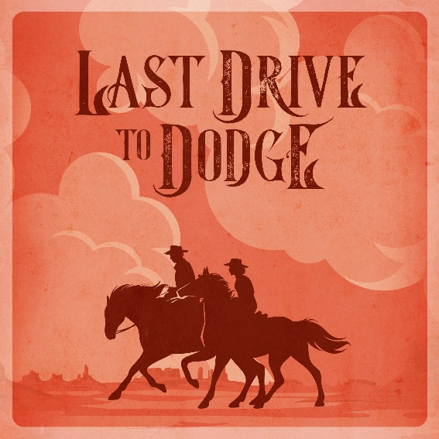
STORY OF THE STORY
Last Drive to Dodge is one play in a series of plays that playwright Andrew Lee Creech dreams of creating. An ambitious project entitled, “The Legacy Plays” this series will be a play cycle which uses specific moments in American history as touchstones to shine a light on untold stories, to examine the full breadth of my community’s humanity and rich history, to add more Black narratives and roles to the American theatre canon, and to reconcile the barrier between American history and Black history--reframing how we think about and teach history in general. When completed, the cycle will include nine plays, spanning from the end of American slavery and into the 21st century, with the goal of reconciling one history.
When asked about his inspiration for Last Drive to Dodge, Creech wrote:
“I’ve always loved movies for as long as I can remember--movies of all genres…except Westerns, which I couldn’t stand the idea of watching for a long time. But objectively, I should’ve loved them. They’ve got action, daring escapes, romance, awesome dialogue, larger than life characters--all things I like, but for some reason, I couldn’t bring myself to watch them.
Reflecting back, I now realize that I didn’t like Westerns because I never felt like I was invited to like them. I rarely saw anyone in them who looked like me, and I didn’t feel seen, myself. Perhaps that’s why I gravitated towards Blazing Saddles. At any rate, the Western was a genre in which I felt as though I could only watch, not participate.
Now, the writer in me goes, “Where are the Black cowboys? What were their lives like during this time? Where are their stories and why aren’t they stage?” And the more research I did, the more fascinated I became with the time period. There was no shortage of Black people and figures in the American Frontier. But I had hardly heard of any.
The American West is an overly romanticized and whitewashed period in American history. So I wanted to write a story set in that time period with Black people as the protagonists, and in a romance all their own. But I didn’t want to write a sprawling, gunslinging, bull or horse riding epic. I wanted to tell a small scale story with large scale implications. Not overly romanticized. Not outrageous. But human, and grounded in the social and political realities of the ranching industry in the late 19th century. So while this play may not be a Western in the true sense, it is built on the genre’s bones. And in the same way I desired when I felt I couldn’t participate, I want these characters and people to be seen--with all their love, their challenges, their joy, their faults, and their vulnerabilities.”

U.S. Historical Timeline
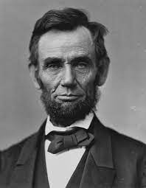
1863 As part of a Civil War military strategy, President Abraham Lincoln signs the Emancipation Proclamation, declaring that the majority of the nation's slave population "henceforth shall be free."
1865 By 1865, some 180,000 Black men have served in the Union Army, over one-fifth of the adult male black population under 45.
1865 Marching the Union Army through the South with an ever-growing number of freed slaves in its wake, General William Tecumseh Sherman issues Special Field Order 15, setting aside part of coastal South Carolina, Georgia, and Florida by settlement exclusively by Black people. The settlers are to receive "possessory title" to forty-acre plots.
1865 June 19, 1865, when some 2,000 Union troops arrived in Galveston Bay, Texas. The army announced that the more than 250,000 enslaved Black people in the state, were free by executive decree. This day came to be known as "Juneteenth," by the newly freed people in Texas and continued to be an annual holiday in many African American communities. Juneteenth was established as a federal holiday in 2021.
1865 The Thirteenth Amendment, abolishing slavery throughout the Union, wins Congressional approval and is sent to the states for ratification.
1865 The temporary Bureau of Refugees, Freedmen, and Abandoned Lands is established within the War Department. The Freedman's Bureau works to smooth the transition from slavery, providing formerly enslaved people with immediate shelter and medical services, help in negotiating labor contracts with landowners, and more.
1865 General Robert E. Lee, as commander in chief of Confederate forces, surrenders his 27,000 man army to Ulysses S. Grant at Appomattox Court House, Virginia, effectively ending the four years of Civil War conflict.
1865 Abraham Lincoln is assassinated in Ford's Theatre, Washington, D.C.. five days after the signing at Appomattox of the Confederate surrender.
1865 The Thirteenth Amendment, abolishing slavery, takes effect.
1865 President Johnson announces his plan of Presidential Reconstruction. It calls for general amnesty and restoration of property -- except for formerly enslaved people -- to all Southerners who will swear loyalty to the Union. This Reconstruction strategy also requires states to ratify the Thirteenth Amendment, ending slavery. The president's plan is implemented during the summer.
1866 The Civil Rights Act of 1866 is passed by Congress, the first federal law protecting the rights of African Americans. It is vetoed by President Johnson, but the veto is overridden by Congress.
1866 The final Congressional elections of the year and election of additional Republicans lead to southern reconstruction being taken over by the federal government and freedman's rights backed.
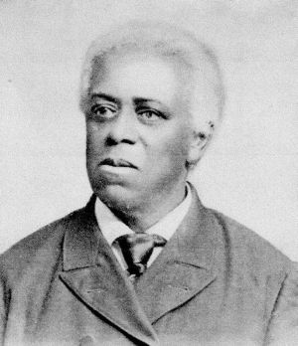
1866 Edward G. Walker and Charles L. Mitchell are the first Black men to sit in an American legislature, that of Massachusetts.
1866 The Klu Klux Klan forms secretly to discourage Black people from voting, issuing in a brutal and shameful era of terror and crime amid southern states as civil rights for freed slaves emerged from the Civil War Era and made hesitant progress throughout the majority of the 20th Century.
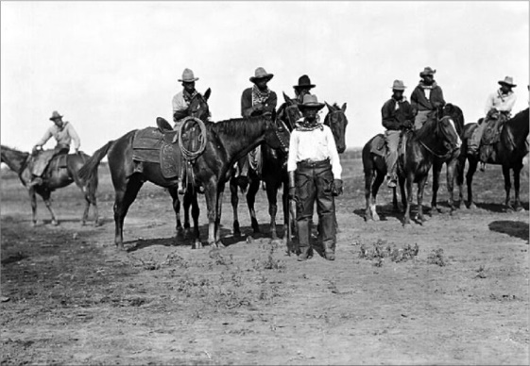
1866 The first Long Drive. Texas cattlemen hire cowboys to drive cattle to the northern states where the price of beef is higher. The tradition of the “cattle drive” is born.
1867 Secretary of State William H. Seward consummates the sale of Alaska to the United States from Russia for $7.2 million dollars, approximately two cents per acre, by signing the Treaty of Cession of Russian America to the United States.
1867 First of twelve installments of Ragged Dick by Horatio Alger is published and one year later expanded into a book in the "rags to riches" theme.
1867 The Grange organizes to protect the interest of the American farmer.
1867 Joseph McCoy, a Chicago cattle dealer, founded the ‘cow town’ of Abilene, Texas.
1868 Thomas Edison applies for his first patent for the electric vote recorder.
1868 Republican Ulysses S. Grant, with Shuyler Colfax as his running mate, proves victorious in his quest to become the 18th President of the United States.
1868 The South Carolina House became the first and only legislature to have a Black majority, 87 Blacks to 40 whites.
1869 At Promontory, Utah, the final golden spike of the transcontinental railroad is driven into the ground, marking the junction of the Central Pacific and Union Pacific Railroads. This act, as much as any other, would signal the marked increase in the settlement of the west.
1869 In one of the first acts of success in the women's suffrage movement, a Women's Suffrage law passes in the Territory of Wyoming.
1870 The first African-American to be sworn into office in the United States Congress, Hiram Rhodes Revels, a Republican from Mississippi takes his place in the United States Senate.
1870 The 15th Amendment to the Constitution is declared ratified by the Secretary of State. It gave the right to vote to Black Americans. Race would officially no longer be a ban to voting rights.
1870 The last former state of the Confederacy, Georgia, is readmitted into the Union, and the Confederated States of America is officially dissolved.
1871 The first professional baseball league, the National Association, debuts with a game between the Cleveland Forest Citys and the Fort Wayne Kekiongas. Fort Wayne won the initial official game 2 to 0.
1871 Wild Bill Hickcock (Buffalo Bill) was employed as Marshall of Abilene.
1872 The world's first national park is established when President Grant signs legislation enabling the establishment of Yellowstone National Park in the states of Wyoming, Montana, and Idaho.
1873 Jesse James and the James-Younger Gang engage in the first successful train robbery in the American West, taking three thousand dollars from the Rock Island Express at Adair, Iowa.
1873 The Seventh Cavalry under the command of Lt. Colonel George Armstrong Custer, protecting a railroad survey party in Montana, engage the Sioux for the first time near the Tongue River in one minor clash of the “Indian Wars”.
1873 An economic depression begins when the New York stock market crashed- The panic of 1873, setting off a financial panic that caused bank failures. The impact of the depression would continue for five years, and lead to widespread unemployment.
1873 Timber Culture Act This Act was an extension to the Homestead Act offering 160 acres of land for free provided that at least 40 acres was planted with trees.
1874 The political tide has finally turned in the Democrats' favor; they win control of Congress as stories of black political corruption, continued Southern violence, and a terrible economic depression occupy public attention.
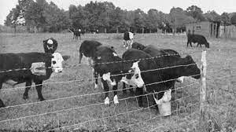
1874 Barbed wire invented. F Glidden invented barbed wire. This invention meant that large areas of land could be fenced relatively cheaply.
1875 As one of its last acts, the Republican-led Congress passes the Civil Rights Bill of 1875, prohibiting segregation in public facilities. The law will stand only until 1883, when the U.S. Supreme Court will strike it down.
1875 Reporting on the “Indian Wars,” inspector E.C. Watkins pronounces that hundreds of Sioux and Cheyenne under Indian leaders Sitting Bull and Crazy Horse are openly hostile against the United States government, forming U.S. policy over the next year that would lead to battles such as Little Big Horn.
1876 Original date issued by the United States government ordering all Native Americans onto a system of reservations throughout the western lands of the United States. Although the date would be extended by President Grant, this issue would lead to the Great Sioux War of 1876.
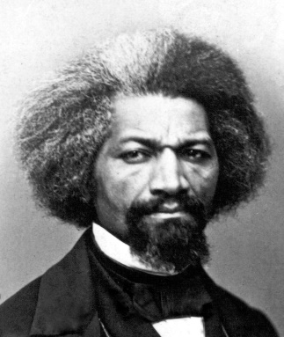
1876 The Philadelphia Centennial Exhibition, a world's fair meant to celebrate the 100th birthday of the United States opens on 285 acres in Fairmount Park, Philadelphia. Among its notable public showings include Alexander Graham Bell, with his newly patented telephone and Thomas Edison with the megaphone and phonograph. Unfortunately, the Centennial Exhibition excluded any meaningful representation of African American culture or achievements. Frederick Douglass, arguably the greatest orator of his time, was invited to sit on the main platform on opening day, but was not invited to speak. Furthermore, he was almost denied entrance to the platform by police who refused to honor his ticket, incredulous that a Black man would be welcome in the company of President Grant and the other dignitaries on the dais.
1876 The Battle of Little Big Horn occurs when Lt. Colonel George Custer and his 7th U.S. Cavalry engage the Sioux and Cheyenne Indians on the bluffs above the Little Big Horn River. All 264 members of the 7th Cavalry and Custer perish in the battle, the most complete rout in American military history.

1877 Following a bitterly disputed presidential contest between Republican Rutherford B. Hayes and Democrat Samuel Tilden, in which both candidates claim victory, Hayes is declared president. In a back-room political deal, the Republicans agree to abandon Reconstruction policies in exchange for the presidency.
1877 Reconstruction policies officially end. The South codifies and enforces segregation. Violations of Black civil rights will not command national attention again until after World War II.
1877 Indian leader of the Oglala Sioux, Crazy Horse, surrenders to the United States Army in Nebraska. His people had been weakened by cold and hunger.
1877 Frederick Douglass, the civil rights leader and abolitionist moved into his house, Cedar Hill, in the Anacostia section of Washington, D.C.
1877 Desert Land Act. This Act allowed farmers to buy 640 acres of land at a cheap price in areas where there was little rainfall and irrigation schemes were needed to farm the land.
1878 Thomas Edison patents the cylinder phonograph or tin foil phonograph. The Edison Electric Company begins operation.
1879 President Rutherford B. Hayes signs a bill that allowed female attorneys to argue in Supreme Court cases.
1881 Notorious outlaw, Billy the Kid, was shot by lawman Pat Garratt
1881 The Tuskegee Institute for Black students training to be teachers opens under the tutelage of Booker T. Washington as instructor in Tuskegee, Alabama.
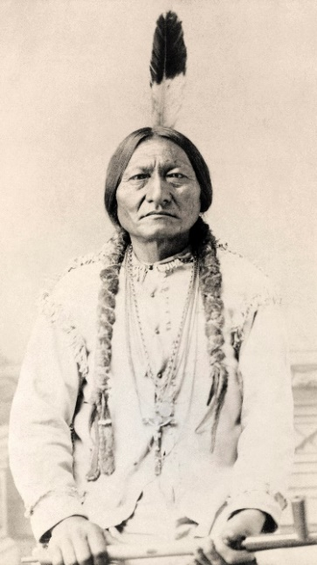
1881 Sioux chief Sitting Bull leads the final group of his tribe, still fugitive from the reservation, and surrenders to United States troops at Fort Buford, Montana.
1882 Western outlaw Jesse James is shot to death by Robert Ford, a member of his own band, for a $5,000 reward. The Ford brothers had been recruited to rob the Platte City Bank, but opted to try to collect the reward for their infamous leader.
1883 The Pendleton Civil Service Reform Act is passed by Congress, overhauling federal civil service and establishing the U.S. Civil Service agency.

1883 Vaudeville, the entertainment and theatrical phenomena, begins when the first theatre is opened in Boston, Massachusetts. Boston, by 1883, was a vibrant town of over 360,000 people.
1883 The U.S. Supreme Court finds part of the Civil Rights Act of 1875 unconstitutional, allowing individuals and corporations to discriminate based on race.
1883 Five standard time zones are established by the United States and Canadian railroad companies to end the confusion over thousands of local time zones.
1884 The Federation of Organized Trades and Labor Unions in the U.S.A. call for an eight-hour workday.
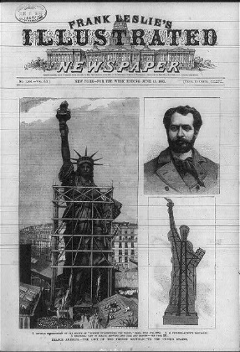
1885 The Statue of Liberty arrives for the first time in New York harbor. Construction woiuld not be complete until 1886.
1885 The Washington Monument is dedicated at a ceremony by President Chester A. Arthur.
1885 White coal miners attack Chinese laborers in the Wyoming territory during what comes to be known as the Rock Springs Massacre. Twenty-eight Chinese are killed, with 15 more injured by the mob, which also looted and set fire to all of the homes in the area’s Chinatown.
1885 President Ulysses S. Grant, Civil War hero of federal forces, dies in Mt. McGregor, New York.
1885 American Telephone and Telegraph (ATT) is incorporated in New York City as a subsidiary of American Bell Telephone Company.
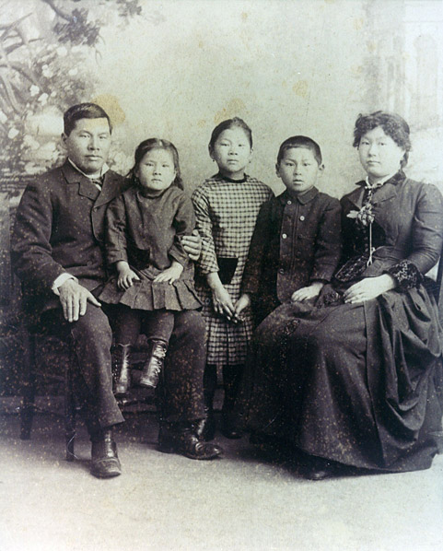
1885 In the case Tape v. Hurley, California's Supreme Court rules that the state entitles "all children" access to public education. The case centers on Mamie Tape, then 8, an American-born daughter of Chinese immigrants whose family sued the San Francisco Board of Education for denying her admission because of her race.
1885 At Grace Church in New York City, Episcopal Priest Samuel David Ferguson becomes the first Black bishop of the American House of Bishops.
1886 Dr. John Pemberton, a Georgia pharmacist, invents Coca-Cola, a carbonated beverage.
Joseph, Emily, Mamie, Frank, and Mary Tape, 1885
1886 Black Knights of Labor Members: The Knights of Labor grows to between 50,000 and 60,000 Black members. This labor organization founded to secure additional protections and increased wages for laborers is one of the nation's first national labor movements.
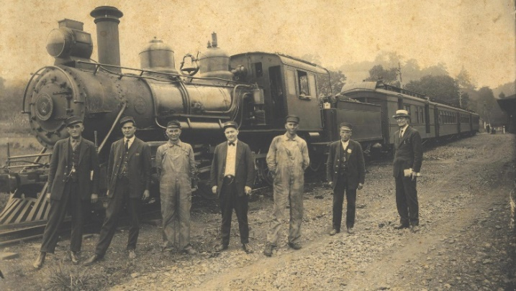
1887 Congress passes the Interstate Commerce Act to regulate and control the monopolies of the railroad industry.
1887 General Allotments Act (Dawes Act). This Act split up most of the remaining “Indian land” into 160 acre plots. Some of the plots were given to Native Americans but much of the land was allocated to white settlers.
1889 Florida Poll Tax: Florida institutes the poll tax as a requirement for voting in order to disenfranchise Black men. Many western and southern states, including Texas, Mississippi, North and South Carolina, and others, do the same.
1890 The Sherman Anti-Trust Act becomes law in the United States.
1890 The Wounded Knee Massacre takes place in South Dakota when U.S. Cavalry troopers fired on a gathering of the Lakota Sioux. The killing of hundreds of unarmed men, women, and children essentially marked the end of Native American resistance to white rule in the West.

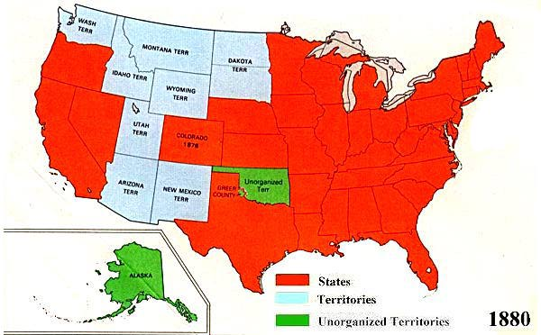
U.S. Territorial Map 1880

Reconstruction: u.s. history
“The Emancipation Proclamation in 1863 freed African Americans in rebel states, and after the Civil War, the Thirteenth Amendment emancipated all U.S. slaves wherever they were. As a result, the mass of Southern Black people now faced the difficulty that Northern Black people had confronted—that of a free people surrounded by many hostile whites. One freedman, Houston Hartsfield Holloway, wrote, “For we colored people did not know how to be free and the white people did not know how to have a free colored person about them.”
Even after the Emancipation Proclamation, two more years of war, service by African American troops, and the defeat of the Confederacy, the nation was still unprepared to deal with the question of full citizenship for its newly freed Black population. The Reconstruction implemented by Congress, which lasted from 1866 to 1877, was aimed at reorganizing the Southern states after the Civil War, providing the means for readmitting them into the Union, and defining the means by which white people and Black people could live together in a non-slave society. White leaders in the South, however, saw Reconstruction as a humiliating, even vengeful imposition and did not welcome it.
During the years after the war, Black and White teachers from the North and South, missionary organizations, churches and schools worked tirelessly to give the emancipated population the opportunity to learn. Formerly enslaved people of every age took advantage of the opportunity to become literate. Grandfathers and their grandchildren sat together in classrooms seeking to obtain the tools of freedom.
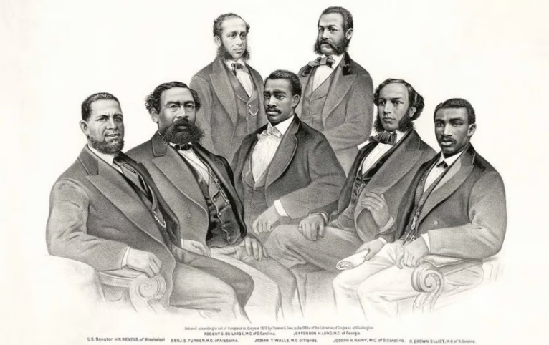
After the Civil War, with the protection of the Thirteenth, Fourteenth, and Fifteenth Amendments to the Constitution and the Civil Rights Act of 1866, African Americans enjoyed a period when they had the power of the vote, actively participated in the political process, acquired the land of former owners, sought their own employment, and used public accommodations. White opponents of this progress, however, rallied against this self-empowerment and began to find means for eroding the gains for which many had shed their blood.”
A lithograph showing the first Black senator and first Black House members, all of whom were elected in Southern states during Reconstruction.
“The African American Odyssey A Quest for Full Citizenship: Reconstruction and Its Aftermath.” Library of Congress. Date Accessed: 19 June 2023, https://www.loc.gov/exhibits/african-american-odyssey/reconstruction.html

Reconstruction Timeline
1861 - 1865 The US Civil War.
1865 Assassination of President Lincoln. Vice President Andrew Johnson became President. The Freedmen’s Bureau established to help former slaves and poor whites in the South. The Thirteenth Amendment abolished slavery.
1865 - 1867 Presidential Reconstruction under Johnson. Black Codes passed by Southern states, establishing slavery in all but name.
1866 Civil Rights Act defined all persons born in the United States as citizens regardless of race. It also established equality before the law regardless of race.
1867 Radical Reconstruction began under Congress. Reconstruction Acts placed federal troops in the South.
1868 Fourteenth Amendment forced all states to protect rights regardless of race. States would later be forced to approve the Fourteenth Amendment if they wanted to re-enter the Union.
1870 All formerly Confederate states had rejoined the Union. The Fifteenth Amendment forbade voter restrictions based on race.
1872 Congress, pressured by white Southerners, disbanded the Freedmen's Bureau.
1873 The Supreme Court and the Slaughterhouse Cases. These Cases reduced the protections of the Fourteenth Amendment. Economic depression.
1875 Civil Rights Act passed which forbade discrimination on public transport and in restaurants. It was poorly enforced.
1876 All but 2 Southern states had Democratic governments restored. They pressured Northern Republicans to withdraw federal troops from the South. Controversial Presidential election where results were disputed.
1877 Compromise of 1877 where Republican Presidential candidate Hayes agreed to withdraw troops from the South in exchange for the Presidency. This signaled the end of Reconstruction.
“Era of Reconstruction”. Study Smarter. Date Accessed: 19 June 2023, https://www.studysmarter.us/explanations/history/emergence-of-usa-as-a-world-power/era-of-reconstruction/
This link to a slideshow for Texas teachers gives a very good overview of the Reconstruction Era and events that are specific to the people of Texas.
https://education.texashistory.unt.edu/downloads/documents/7/units/reconstruction/lessons/impacts-of-reconstruction/english/slideshow.pdf
Black migration to the west
EARLY MIGRATION
“As the nineteenth century progressed, the United States invaded more Native American territory and extended its boundaries farther westward. The promise of land ownership lured thousands of migrants to frontier areas, where they established homesteads, farms, and communities. Thousands more moved to northern California after gold was discovered there in 1848.
Among the "forty-niners" who flocked to California were free Blacks who traveled over miles of harsh and unfamiliar terrain. The migration, fueled by "gold fever," caused California's population to mushroom, and helps to explain why California had the largest Black population in the West during the years before the Civil War.
One of the gold rush migrants was Biddy Mason (1818-1891). Mason and her three daughters walked the nearly two thousand miles from Mississippi to California behind their master's wagon, herding cattle the entire way. When her master decided to return to Mississippi in 1856, Mason sued for and won her family's freedom and their right to remain in California, a free state.
COWBOYS
The frontier state of Texas also had a large Black population by western standards. Cattle raising was an important part of the Texas economy, and enslaved Blacks were among the workers who tended the herds. In the aftermath of the Civil War, cowboys were increasingly in demand to herd cattle along trails to northern railroad depots on their way to market. A substantial number of these cowboys were Black. Although they earned wages comparable to their white counterparts, Black cowboys generally had the low-status job of horse wrangler and seldom became crew chiefs.
Some Black cowboys found a measure of fame as skilled riders and ropers. Bill Pickett (c.1860-1932), a star of the Miller and Lux Wild 101 West Show, invented the rodeo event known as bulldogging. Nat Love (1854-1921), also known as "Deadwood Dick," spent years as a cowboy in the Southwest and became a Pullman porter after his retirement. His name lives on through a series of dime novels written by Edward L. Wheeler and through his own autobiography, which chronicles his life as a cowboy in sometimes unbelievable terms.
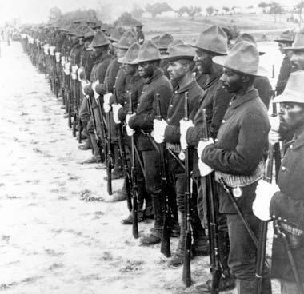
THE BUFFALO SOLDIERS
Cowboys were not the only Black Americans to ride the range. Members of the Ninth and Tenth cavalries and Twenty-fourth and Twenty-fifth infantries, better known as the "buffalo soldiers," maintained a constant presence on the western frontier. They performed such essential tasks as fire fighting, building and maintaining military posts and telegraph lines, and protecting stagecoaches and mail routes.
They also served as a police presence in areas where there was a lack of adequate law enforcement. In many frontier areas, the soldiers were the most reliable source of law and order available. Their work included everything from settling civil disputes among settlers to capturing cattle thieves and murderers. Their most important duty, however, was to defend settlers and their land disputes with the Native Americans tribes. The buffalo soldiers were involved in battles with the Comanche, Kiowa, southern Cheyenne, and Arapaho Indian nations, to name a few.
The buffalo soldiers battled more than Native Americans. In some cases, their worst enemies were the very civilians whose lives they were sworn to protect. In 1892, soldiers from the Ninth Cavalry were dispatched to Johnson County, Wyoming, to maintain order between stock growers and cattle rustlers during the Johnson County War. There they found themselves the targets of some white citizens in Suggs, Wyoming, who violently objected to the soldiers' presence. Tensions between white settlers and the Black soldiers led to a shootout that left one soldier dead.
At other times, though, Black soldiers were treated with respect by the white settlers. Their treatment was dependent upon a number of factors, most notably the threat from Native Americans.
EXODUSTERS AND BLACK TOWNS
Black settlers throughout the West experienced the same uncertain treatment as the buffalo soldiers. Generally, the abundance of cheap land and the pioneers' reliance on each other made for fairly peaceful relations between Black and white settlers. But as frontier areas became more populous, settled, and "civilized," old patterns of prejudice and white supremacy began to emerge.
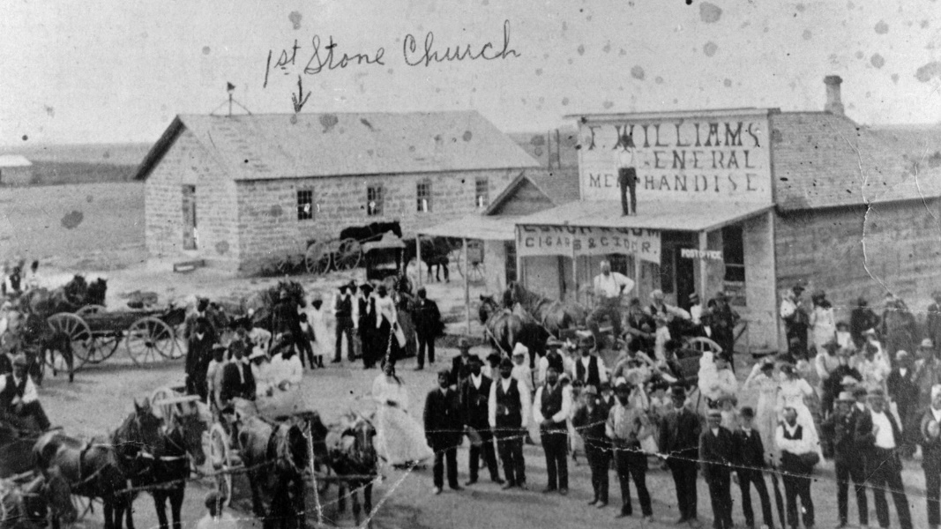
Nevertheless, thousands of African American migrants swarmed into Kansas beginning in 1879, when conditions in the South after Reconstruction had become unbearable. The lack of economic and political opportunity, as well as state-sanctioned racial violence, drove them from their homes. The hope for a better life and the promises of land speculators, both black and white, drove them on. More than twenty thousand Black Americans migrated to Kansas and other parts of the West between 1879 and 1880.
This migration, called the "Exoduster" movement, was led by Benjamin "Pap" Singleton (1809-1892), a seventy-year-old man who was motivated by religious faith to help deliver his people to the promised land of Kansas. Families gathered themselves and all the belongings they could carry and boarded river boats traveling up the Mississippi River. Migrants then traveled on foot or by horse or wagon to reach a place where their lives and their rights might be respected.
The migration caused a national outcry. White landowners in the South feared the loss of their cheap labor force. The Exodusters encountered many hardships upon their arrival. In 1880, Congress formed a special committee to investigate the causes of the migration.
From the Exoduster movement emerged a host of Black towns in Kansas and neighboring Oklahoma. Towns such as Nicodemus, Kansas, and Langston, Oklahoma, were founded in the 1880s by Black people, primarily as agricultural communities. Farther west, Black towns such as Blackdom, New Mexico; Allensworth, California; and Deerfield, Colorado; were founded as places where African American settlers might attain economic and political self-sufficiency. For a variety of reasons, most of these towns failed, and their residents moved away. Nicodemus is one of the few still in existence today.
COMMUNITY
As a result of the Exoduster movement and increased migration westward after the Civil War, the Black population in the west grew rapidly. Even with the increase, however, it remained very small, and in most western states this is still the case. For instance, the largest number of African Americans living in Nevada in the nineteenth century was 396, in 1880. Moreover, the majority of Black frontier settlers were men. In turn-of-the-century Los Angeles, Black females were so scarce that black men "inspected" incoming trains, looking for possible mates.
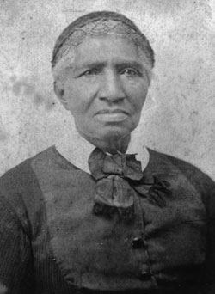
Those Black women who did travel west were usually older and better educated than Black women in general and they were often better educated than the average white woman on the frontier. Any woman traveling alone faced dangers specific to her sex, and for Black women the dangers were compounded by their race. Despite the risks, Black women did migrate west. One such woman was Clara Brown (1800-1885 pictured to the left), who at the age of fifty-five traveled from St. Louis to Denver in a covered wagon.
Once migrants settled in their new homes, the isolation and separation from friends and family could be frightening. One migrant to Seattle described the experience: "There were few of our people in Seattle when we came in 1889 and at times, I got very lonely. "Despite their small numbers, African Americans throughout the West attempted to duplicate familiar community structures such as the church, lodges, and benevolent societies.
Women were especially active as community builders. Lucy Phillips, who moved to Cheyenne, Wyoming, with her family in 1868, donated land for the Allen A.M.E. Church and held meetings in her home in the years before the chapel was built. In Central City, Colorado, Clara Brown became active in church and charitable causes and used some of her earnings as a laundress to help over thirty members of her family relocate to Colorado.
Family and community ties have always been an important feature of the African American experience, and western migrants developed a number of ways to maintain theirs. Pullman porters on the transcontinental railroad served as an informal but critical link between eastern and western Black communities. Often, they encouraged migration by carrying messages between family members and serving as examples of opportunities the West had to offer.
The West also had a thriving Black press. California was home to several Black newspapers, including the Western Appeal, the Mirror of the Times, and the San Francisco Elevator. The columns of these papers were filled with letters from African American correspondents writing from all over the west.
CHANGING IDEAS OF THE FRONTIER
Today, the frontier lives on as one of the most enduring American symbols, a land of cowboys, shootouts, and wide-open spaces. But many of our perceptions about the West come from television, movies, and books that have romanticized the frontier experience and ignored some of its realities. The precise meanings of "the West" and "the Frontier" are still being debated today.
As the debate rages on, historians attempt to make history more inclusive, gathering information about people like African Americans whose experience is often ignored in popular myths of the frontier. Such work gives us a truer and more interesting account of how all Westerners—not just cowboys—led their lives on the frontier.”
Shorter, Stacy. “African Americans on the Frontier.” Encyclopedia.com. c.2016. Date Accessed August 7, 2023.
Nodjimbadem, Katie. “Lesser Known History of African American Cowboys.” Smithsonian Magazine. Published: 12 February 2017, https://www.smithsonianmag.com/history/lesser-known-history-african-american-cowboys-180962144/

Black cowboys
Selections from an Article from Smithsonian Magazine
The Lesser-Known History of African-American Cowboys by Katie Nodjimbadem
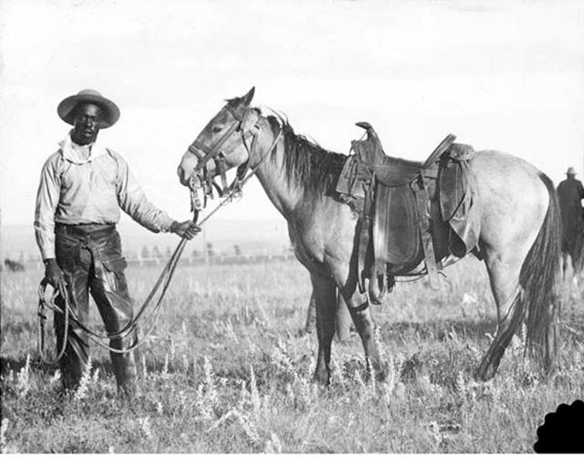
“In his 1907 autobiography, cowboy Nat Love recounts stories from his life on the frontier so cliché, they read like scenes from a John Wayne film. He describes Dodge City, Kansas, a town smattered with the romanticized institutions of the frontier: “a great many saloons, dance halls, and gambling houses, and very little of anything else.” He moved massive herds of cattle from one grazing area to another, drank with Billy the Kid and participated in shootouts with Native peoples defending their land on the trails. And when not, as he put it, “engaged in fighting Indians,” he amused himself with activities like “dare-devil riding, shooting, roping and such sports.”
Though Love’s tales from the frontier seem typical for a 19th-century cowboy, they come from a source rarely associated with the Wild West. Love was African-American, born into slavery near Nashville, Tennessee. Few images embody the spirit of the American West as well as the trailblazing, sharpshooting, horseback-riding cowboy of American lore. And though African-American cowboys don’t play a part in the popular narrative, historians estimate that one in four cowboys were black.
The cowboy lifestyle came into its own in Texas, which had been cattle country since it was colonized by Spain in the 1500s. But cattle farming did not become the bountiful economic and cultural phenomenon recognized today until the late 1800s, when millions of cattle grazed in Texas.
White Americans seeking cheap land—and sometimes evading debt in the United States—began moving to the Spanish (and, later, Mexican) territory of Texas during the first half of the 19th century. Though the Mexican government opposed slavery, Americans brought enslaved Blacks with them as they settled the frontier and established cotton farms and cattle ranches. By 1825, enslaved peoples accounted for nearly 25 percent of the Texas settler population. By 1860, fifteen years after it became part of the Union, that number had risen to over 30 percent—that year’s census reported 182,566 enslaved African-Americans living in Texas.
As an increasingly significant new slave state, Texas joined the Confederacy in 1861. Though the Civil War hardly reached Texas soil, many white Texans took up arms to fight alongside their brethren in the East.
While Texas ranchers fought in the war, they depended on those they had enslaved to maintain their land and cattle herds. In doing so, these enslaved Blacks developed the skills of cattle tending (breaking horses, pulling calves out of mud, and releasing longhorns caught in the brush, to name a few) that would render them invaluable to the Texas cattle industry in the post-war era.
But with a combination of a lack of effective containment— barbed wire was not yet invented—and too few cowhands, the cattle population ran wild. Ranchers returning from the war discovered that their herds were lost or out of control. They tried to round up the cattle and rebuild their herds with slave labor, but eventually the Emancipation Proclamation left them without the free workers on which they were so dependent. Desperate for help rounding up maverick cattle, ranchers were compelled to hire now-free, skilled African-Americans as paid cowhands.
“Right after the Civil War, being a cowboy was one of the few jobs open to men of color who wanted to not serve as elevator operators or delivery boys or other similar occupations,” says William Loren Katz, a scholar of African-American history and the author of 40 books on the topic, including The Black West.
Freed blacks skilled in herding cattle found themselves in even greater demand when ranchers began selling their livestock in northern states, where beef was nearly ten times more valuable than it was in cattle-inundated Texas. The lack of significant railroads in the state meant that enormous herds of cattle needed to be physically moved to shipping points in Kansas, Colorado and Missouri. Rounding up herds on horseback, cowboys traversed unforgiving trails fraught with harsh environmental conditions and attacks from Native Americans defending their lands.
African-American cowboys faced discrimination in the towns they passed through—they were barred from eating at certain restaurants or staying in certain hotels, for example—but within their crews, they found respect and a level of equality unknown to other African-Americans of the era.
Love recalled the camaraderie of cowboys with admiration. “A braver, truer set of men never lived than these wild sons of the plains whose home was in the saddle and their couch, mother earth, with the sky for a covering,” he wrote. “They were always ready to share their blanket and their last ration with a less fortunate fellow companion and always assisted each other in the many trying situations that were continually coming up in a cowboy's life.” ...
Black Cowboys: Nodjimbadem, Katie. “Lesser Known History of African American Cowboys.” Smithsonian Magazine. Published: 12 February 2017, https://www.smithsonianmag.com/history/lesser-known-history-african-american-cowboys-180962144/
Black Women on the Frontier: https://www.sigtheatre.org/events/201920/gp/the-african-american-women-of-the-wild-west
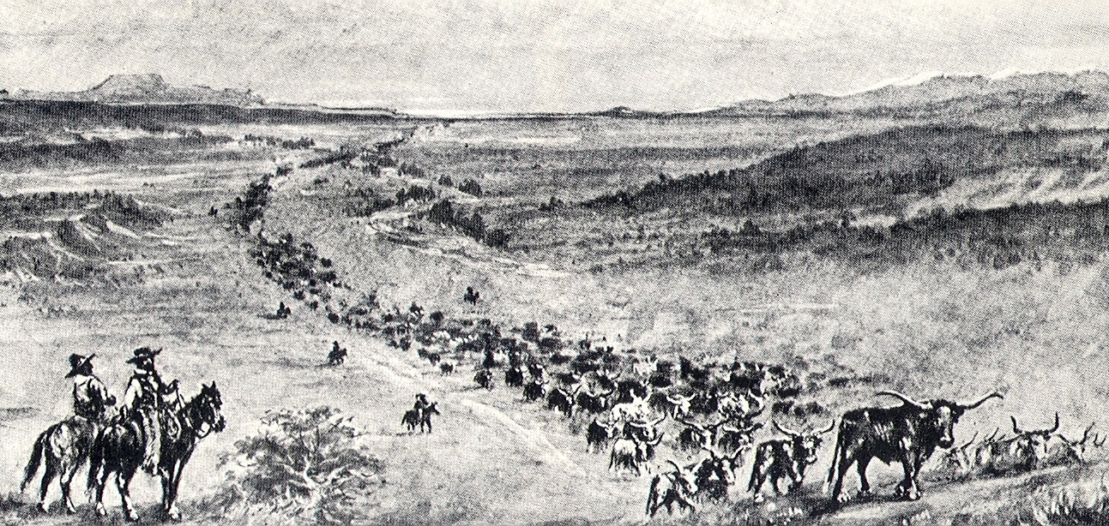
Cattle Drives
No single endeavor has marked the image of Texas in the national mind more than the cattle drive. For more than a century, writers have romanticized the work and the life of the cowboy.
The Peak Period for Cattle Drives
Cattle drives to northern and western markets, and later to railroad-loading facilities, started in earnest in 1866, when an estimated 260,000 head of cattle crossed the Red River. The drives were conducted for only about 20 years, becoming unnecessary with the advent of the railroads and refrigeration in the 1880s.
Cattle drives usually began in the spring after roundup, as grass was available then and the herd could be delivered to its destination in the north before cold weather set in. Livestock from several different owners was usually included in a trail herd. The trail boss obtained documentation from each rancher noting the owner's brand, earmark, and number of cattle. Then all animals in the drive were branded with the same road brand, regardless of ownership.
A 12-man crew could manage a herd of 2,000 to 3,000 head. The trail boss was the ultimate authority on the trail, like the captain of a ship, and was paid $100 to $125 a month. Of the rest of the crew, the cook was the most important, earning about $60 per month.
Legendary ranchman and trail driver Charles Goodnight invented the chuckwagon in 1866 for use by his crews. The chuckwagon, sometimes drawn by oxen, but usually by mules, carried not only food, utensils, and a water barrel, but also tools and the crew's bed rolls. A fold-out counter, supported by one or two hinged legs, was used for food preparation. The wagon contained several drawers and shelves, with a "boot" or storage compartment underneath, all covered by a canvas top. The cook served beef and bison steaks, SOB stew (made from calf parts), "chuckwagon chicken" (bacon), "Pecos strawberries" (beans), "sourdough bullets" (biscuits) and cowboy coffee.
There were nine or 10 wranglers and drovers – sometimes called "thirty-dollar men" – per crew. The wrangler managed the herd of spare horses, known as the remuda, made up of eight or 10 horses for each man. The remaining drovers were appointed to their posts along the line of cattle in the drive.
Cattle do not trail in a group, but strung out in a long line. Several natural leaders usually take their places in front, while all the others fall into an irregular line behind them. A herd of 1,000 head might stretch out one to two miles on the trail. The drovers worked in pairs, one on either side of the line of animals. The best of the men were usually assigned to be "pointers," working near the head of the line. The remainder of the men worked the flank and swing positions farther back, with drag men bringing up the rear. Communication was by hand signals, adapted from Plains Indian sign language, or gestures with hats.
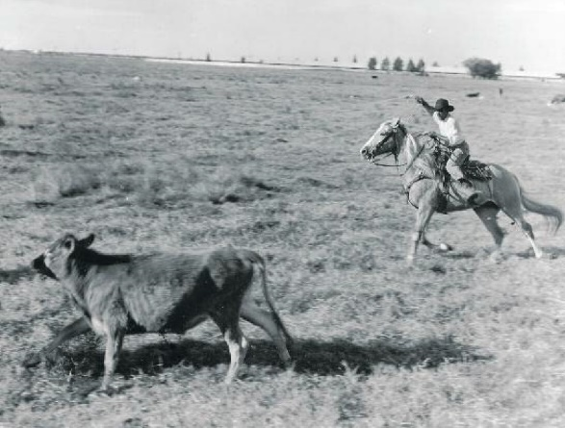
The drive would cover about 10 to 15 miles a day and, depending on what delays were encountered, a drive to western Kansas would take between 25 and 100 days.
Ramos, Mary G. Editor Emerita. “Cattle Drives.” Texas Almanac 1990-1991. Date Accessed August 7 2023/ https://www.texasalmanac.com/articles/cattle-drives

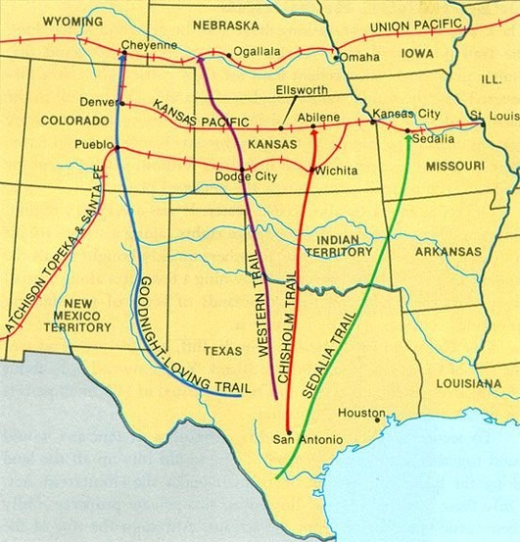
Western Trail

Dramaturg Note:
It’s likely that Bennett and Prophet rode the “Western Trail”—since it’s the most direct route between Texas and Dodge City. This website has a good description of that trail and its history: http://genealogytrails.com/tex/state/cattledrives.html#Western%20Trail
Rancher history
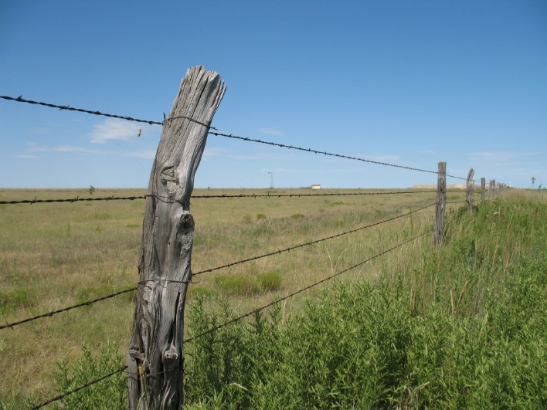
“The Fence Cutting Wars occurred near the end of the 19th century in the American Old West and were a series of disputes between farmers and cattlemen with larger land holdings. As newcomers came to the American West to farm, established cattlemen began to fence off their larger tracts of land with barbed wire in order to protect them from the farmers' claims. The settlers viewed this as a closing of the open range and began to cut fences to attempt to reclaim lands in the public domain. The ensuing, widespread series of conflicts was known as the Fence Cutting Wars.
Under the Homestead Act of 1862, the United States government offered 160 acres (65 ha) of lands in the west to those willing to reside on and improve their land. Farmers who were seeking cheap, plentiful land on which to raise herds of cattle flocked west. Some of these men accumulated more cattle than others, and companies or syndicates began to invest in the big cattle operations. Those with larger holdings of cattle were known as "cattle kings," "cattlemen," or "cattle barons."
Barbed wire, which was patented in 1874, was revolutionary in allowing farmers to protect their claims, crops, and livestock, particularly as the land started to fill up and competition for rights to and use of the land intensified. Barbed wire was a farmer's product at first, but cattlemen eventually adopted it to fence off their larger tracts of land. Barbed wire became an important factor in changing the cattle industry, as the free, open range became parceled off by barbed wire. Because of this development, the West saw the rise of big-pasture companies.
By the 1880s, newcomers' livestock were beginning to overcrowd the herds of the larger cattlemen. The cattle kings began to fence off their lands to protect access to the rangelands and water, which infuriated many homesteaders. There were many cases when large ranch owners not only fenced the property over which they claimed ownership, but also property considered public land. Some homesteaders retaliated by cutting the barbed wire of the fenced areas to give their livestock access to these lands, prompting the fence-cutting wars. Fence cutters were usually small-scale stockmen or farmers who used the free range and resented its appropriation, but also resented the fact that their stock could get tangled in the fences, injuring, or killing the animals.
“Fence Cutting Wars”. Wikipedia. Last Edited 19 April 2023, https://en.wikipedia.org/wiki/Fence_Cutting_Wars
Gard, Wayne. (Last Updated: 2016, September) Fence Cutting. Texas State Historical Association. https://www.tshaonline.org/handbook/entries/fence-cutting
TERMS & CULTURAL REFERENCES
Consumption
“An old and once common term for wasting away of the body, particularly from pulmonary tuberculosis (TB)…The World Health Organization (WHO) in "L'histoire de la tuberculose" notes that: "In 460 BC Hippocrates identified phtisis (the Greek word meaning "consumption") as the most widespread disease of his day and observed that it was almost always fatal. Someone who had tuberculosis seemed literally to be consumed by the disease. That is why they used to speak of 'consumption'"
Davis, Charles Patrick MD, PhD, Medical Editor. “Definition of Consumption.” RxList. Date Accessed: 19 June 2023, https://www.rxlist.com/staph_infection_slideshow_pictures/article.htm

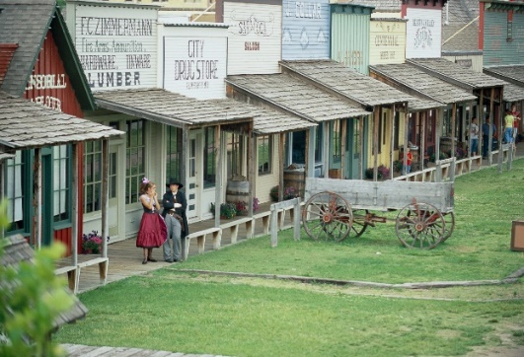
Dodge City, Kansas. “The town of Dodge City can trace its origins to 1871, when rancher Henry J. Sitler built a sod house west of Fort Dodge to oversee his cattle operations in the region, conveniently located near the Santa Fe Trail and Arkansas River, and Sitler's house quickly became a stopping point for travelers. With the arrival of the railroad, in September 1872 Dodge City soon became involved in the cattle trade…
A new route known as the Great Western Cattle Trail or Western Trail branched off from the previous Chisholm Trail to lead cattle into Dodge City. Dodge City became a boomtown, with thousands of cattle passing annually through its stockyards. The peak years of the cattle trade in Dodge City were from 1883 to 1884, and during that time the town grew tremendously…” “Dodge City, Kansas.” Wikipedia. Last Updated: 5 April 2023, https://en.wikipedia.org/wiki/Dodge_City,_Kansas
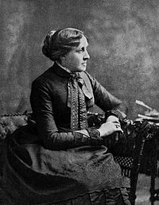
Louisa May Alcott (1832 – March 6, 1888) was an American novelist, short story writer, and poet best known as the author of the novel Little Women (1868) and its sequels Little Men (1871) and Jo's Boys (1886). Raised in New England by her transcendentalist parents, Abigail May and Amos Bronson Alcott, she grew up among many well-known intellectuals of the day, including Margaret Fuller, Ralph Waldo Emerson, Nathaniel Hawthorne, Henry David Thoreau, and Henry Wadsworth Longfellow.
Alcott’s first book was a collection of short stories entitled, Flower Fables (published in 1849). As an adult, Alcott was an abolitionist and a feminist. In 1860, she began writing for the Atlantic Monthly. When the Civil War broke out, she served as a nurse in the Union Hospital in Georgetown, DC, for six weeks in 1862–1863. She intended to serve three months as a nurse, but she contracted typhoid fever and became deathly ill halfway through her service, although she eventually recovered. Her letters home—revised and published in the Boston anti-slavery paper Commonwealth and collected as Hospital Sketches (1863, republished with additions in 1869)—brought her first critical recognition for her observations and humor.”
“Louisa May Alcott.” Wikipedia. Last Edited 30 May 2023, https://en.wikipedia.org/wiki/Louisa_May_Alcott
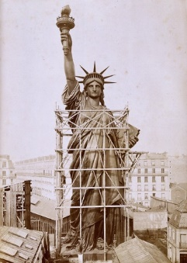
Statue of Liberty. “Liberty Enlightening the World” was a gift of friendship from the people of France to the people of the United States to commemorate the 100th anniversary of American independence. Construction of the statue began in 1875 in France and was completed in 1884. After a presentation ceremony in Paris, the statue was dismantled and shipped to NYC in 214 containers. The statue took its sculptor Bartholdi 10 years to complete, and it took 2 more years to collect money from New York citizens to build the pedestal. The statue was finally installed and dedicated in 1886.

